Figure 1. Jordan Peterson’s pseudo-academic videos celebrating motherhood as women’s meaning.

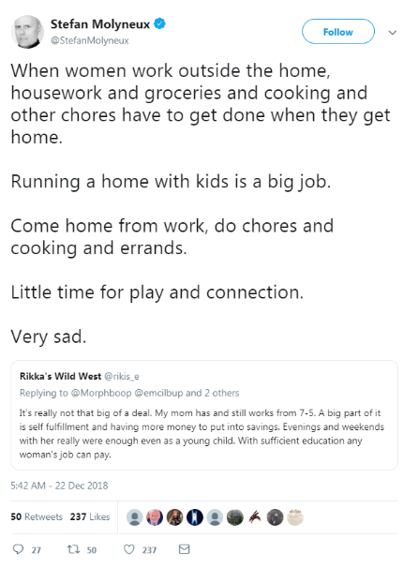
Figure 2. Stefan Molyneux’s tweet about the struggles of working women

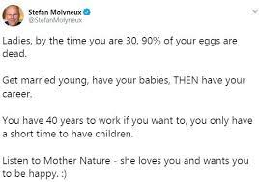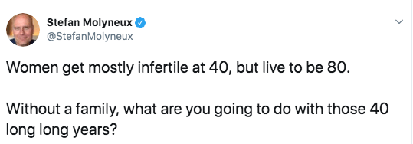
Figure 3. Two more of Molyneux’s tweets clarifying he supports motherhood, not better working conditions for women.

Figure 4. Youtube archive of a morning tv show that celebrates the #Tradwife movement

Figure 5. Two vides from Red Ice TV illustrating the different takes on the great replacement/white genocide conspiracy.

